**What is a 7 Segment Display?**

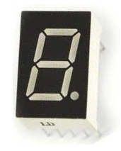

A **7 Segment LED Display** is a electronic device that contains an array of 8 individual LEDs.

Each of the 8 segments that make up the display can be either be on the on state or the off state. Depending on which LEDs are lit determines the character which is displayed on the LED. The LED can be made to show a wide range of characters, including all numerical digits from 0-9.

The versatility of a 7 segment display lies in the fact that it can be a numerical value indicator. LED displays are used in all types of products, including alarm clocks, scoreboards, and all other signs showing character output.

Below is an alarm clock composed of a number of LED displays, showing the time.

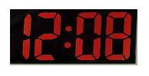

### Types of 7 Segment Displays

There are all types of LED Displays, but as far as wiring and connecting purposes are concerned, there are two main types: common cathode LED displays and common Anode LED Displays.

### Common Cathode LED Displays

The cathode of an LED is the negative terminal of the LED. An LED has two terminals. One side is the anode (the longer lead), which gets hooked up to the positive voltage of the circuit. And the other terminal is the cathode (the shorter lead), which gets hooked up to the negative voltage or the ground of the circuit.

When you have a common cathode seven segment display, which is an array of 8 LEDs, the LED cathodes are all tied together and are common.

Below is a typical LED display, with each LED segment labeled with an alphabetical character.

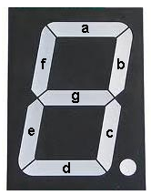

This is how the seven segment display will appear wired up in a common cathode setup:

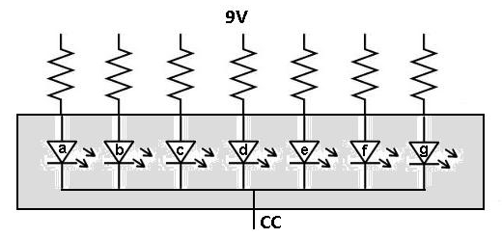

As you can see, all of the positive terminals of the seven segment display are all separate. In order to turn any of the segments on, you supply votlage to the terminal that you want turned on. In order to turn, LED a and b on, you supply each with the necessary. However, on the cathode side, you do not have connect each individual LED to ground. The grounds of the LEDs are all tied together. So once you connect the common ground pin, all of the LEDs are connected to ground. This is a common cathode seven segment LED display.

### Common Anode LED Display

The other type of 7 segment dispaly is the common anode LED display. This is the display in which all of the anode leads of the LEDs are tied together and are common, while the cathode leads are each separate.

Using the same alphanumerical LED diagram which is shown above, a common anode LED display will appear connected as what is shown below:

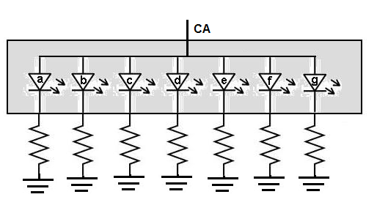

With a common anode display, all the anodes are tied together, so they're common. Once you place voltage on the positive anode pin, they will all have voltage across them. You turn on an LED when you connect it the cathode pin to ground. Those LEDs which you connect to ground turn on. Those which you leave open (unconnected to ground) stay shut off. This is how common anode LED displays work.